中国光雾山-诺水河世界地质公园（四川）
2019年度工作总结

1.公园属地
地质公园名称、所在国家、区域网络：
光雾山-诺水河联合国教科文组织世界地质公园/中国/亚太世界地质公园网络
入选年份/上一次再评估年份：2018年/—
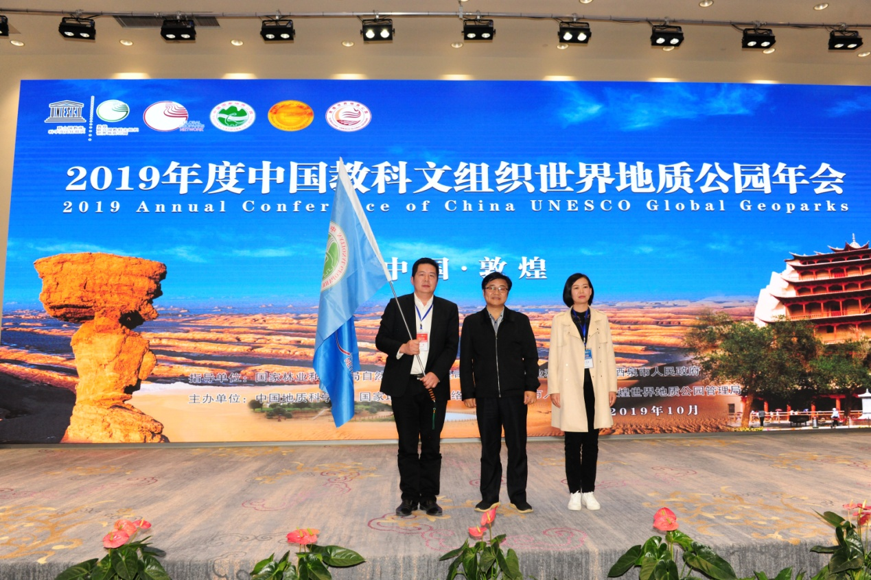
光雾山-诺水河世界地质公园获得2020年中国联合国教科文组织世界地质公园年会主办权
2.地质公园数据
员工数量：51名干部职工，其中：地质专业人员2人，聘请的地质专家1人。
游客人数：110万余人次

地质公园活动数量：开展“4·22世界地球日”、“6·25全国土地日”、光雾山-诺水河世界地质公园知识竞赛、“两馆科普行”、广西桂林泓文学堂等中小学地质研学旅游等20余次科普活动。2019年光雾山-诺水河世界地质公园总接待90万余人次，其中博物馆科普受众达20余万人次，重新修订了公园导游手册、导游图、考察指南、宣传折页等。
开展地质公园教育计划的学校班级数：15个
新闻消息发布数量：60余篇
3.公园活动
2019年主要成就: 参加2019年中国联合国教科文组织世界地质公园年会，并赢得2020年会举办权；完成地质公园石龙寨古生物化石调查、神门景区地质遗迹补充调查及地质公园标本收集等地质遗迹资源调查项目；完成巴中市世界地质公园2个公益广告塔及“一基地三中心”地质科普广场项目建设项目。
对GNN的贡献——参与及网络合作：1）积极参与联合国教科文组织世界地质公园网络合作；2）组织参加了第六届亚太世界地质公园年会并布展；3）赴湘西地质公园开展交流工作；4）2019中国联合国教科文组织世界地质公园年会；5）参加中国世界地质公园主题日活动；6）赴贵州参加旅游地学暨地质文化村落建设考察交流活动；7）参加光雾山研学旅游论坛等国内、国际重要活动。
管理和财务状况：光雾山-诺水河世界地质公园具有统一的管理机构，名称为“中国光雾山-诺水河地质公园管理委员会”，日常工作由四川光雾山-诺水河国家地质公园管理局统一组织开展，主要负责地质公园保护、开发、建设和管理等工作，各县设立了相应的管理机构，主要负责各辖区范围内地质公园的管理。
公园各级管理机构运行经费列入当地财政预算，并实行独立核算，主要依靠上级财政地质遗迹保护项目经费和地方财政拨款。国家投资的各项地质遗迹保护经费作为专项经费。各景区基础设施维护和日常管理开支主要依靠各景区收入。
地质遗迹保护：除开展常态性地质遗迹保护工作外，2019实施完成地质公园古生物化石调查，神门景区地质遗迹补充调查及地质公园化石、岩石、矿物标本收集等三项地质遗迹调查项目；实施完成世界地质公园公益广告塔及地质科普广场建设项目。
可持续旅游（地学旅游）：完成牛角嵌科普广场，龙湖洞、狮子洞、楼房洞等洞穴内灯光照明系统改造工作；完成地质公园标识系统版面更换工作；完成地质博物馆展陈升级改造；地质公园新建旅游厕所8所，改建4所；新增地学研学旅行线路3条。
地质遗迹保护、可持续发展和减少灾害风险方面的新教育项目：完成地质公园范围内、神门景区古生物化石及地质遗迹资源调查评价工作；围绕世界、中国环境保护主题日先后在市内8所中小学校开展相关科普宣传活动，开展科普讲座6场；开展地质公园“研学夏令营”系列活动；与桂林广西泓文课堂等中小学师生开展多形式研学行活动；完成市级教育、爱国科普基地申报工作。
战略合作伙伴：与四川省地质矿产勘查开发局区域地质调查队、脚爬客、西南石油大学、成都理工大学、西华师范大学、四川大学旅游学院建立研产学合作关系；与秦鼎公司建立品牌运营合作关系，与文旅集团建立友好共建关系。
推广营销活动：第17届中国光雾山红叶节和第5届光雾山冰雪节均在地质公园举办，吸引了四面八方游客前来公园观光旅游，红叶节期间每天游客量平均达到4万人次左右，极大地促进了当地旅游收入。在中央电视台、四川电视台、四川日报等各主流媒体进行了宣传。
4.联系人
管理者：许飞 gwsnsh@sina.com
地质学家：范晓

Guangwushan-Nuoshuihe UNESCO Global Geopark,Sichuan, China
Annual Report 2019

1.GEOPART IDENTITY

Guangwushan-Nuoshuihe UNESCO Global Geopark, China, Asia-Pacific Geoparks Network (APGN).

Year of inscription: 2018
Guangwushan-Nuoshuihe UNESCO Global Geopark will have the honor to host 2020 Annual Conference of China UNESECO Global Geoparks
- GEOPARK FIGURES

Number of Geopark staffs: 51 staffs including 2 geoscience professionals and 1 contract geoscientist

Number of Visitors: 1.1 million

Number of Geopark events:

We have held over 20 activities of popular science such as Celebration of World Earth Day on April 22 and National Land Day on June 25, Quiz of Guangwushan-Nuoshuihe UNESCO Global Geopark, Tour of Geological Research and Learning for primary and middle school students of Hongwen, Guilin, Guangxi Province,etc. Among all the visitors last year, around 200,000 of them have visited the Geo-museum. We have also revised travel brochures, tourist maps, field science investigation instructions and such.
Number school classes realize Geopark education programs: 15
Number of Geopark press release: 60
3.GEOPARK ACTIVITIES
Major achievements in 2019:
Attended the 2019 Annual Conference of China UNESECO Global Geoparks and won the host right of 2020 Annual Conference of China UNESECO Global Geoparks.
Finished the research on paleontological fossils found in Shilongzai and the supplementary survey of Geo-heritages in Shenmen. We also concluded the specimen collection for the entire Geopark.
Finished 2 sites of public service advertising in Bazhong City.
Concluded the construction of popular Geo-science plaza of the project of “One-Base-Three-Centers” .
Contribution towards GGN-Networking and Participation
1) Actively involved in GGN-Networking
2) Attended the 6th Annual Conference of Asia-Pacific Geoparks Network (APGN) and set up an exhibition booth
3)Visited Xiangxi Geopark for exchange of ideas
4) Attended the 2019 Annual Conference of China UNESECO Global Geoparks
5) Attended the Theme Day Celebration of UNESECO Global Geoparks of China
6) Attended the field study of earth-science tourism and the building of Geo-cultural Village in Guizhou Province
7) Attended the Guangwushan Tourism Forum of Inquiry-based Learning.
Management and Financial Status：
The Administration Bureau of Guangwushan-Nuoshuihe Global Geopark is responsible for conservation, development and management issues of Guangwushan-Nuoshuihe Global Geopark. Given the two different yet adjacent counties in which the Geopark is located, namely Nanjiang County and Tongjiang County, two subordinate managing bodies are set in place to be held accountable for daily business in their respective area.
Financial budget of the local government, mainly from the superior financial funds designated for geoheritage conservation as well as local financial allocation, covers operating expenses of the managing body at the responding level of the Geopark with an independent accounting. The Central government of China also supports the protection of geoheritage with special funds. And the ticket revenue of scenic spots is used for infrastructure maintenance and daily management.
Geoconservation:
In addition to regular geoconservation, Guangwushan-Nuoshuihe Global Geopark also finished the research on paleontological fossils and the supplementary survey of Geo-heritages in Shenmen. We also concluded the specimen collection including fossils, rocks, and ore for the entire Geopark as well as the public service advertising and the construction of popular Geo-science plaza .
Sustainable tourism(Geotourism)：
1 | Finished the construction of popular Geo-science square of Niujiaoqian
2 | Improved the lighting system within several caves such as Longhu, Lion and Loufang
3 | Revised all signboards for a greater visibility
4 | Upgraded the layout of Guangwushan-Nuoshuihe Global Geopark Museum
5 | Built 8 and rebuilt 4 restrooms within the Geopark
6 | Increased another 3 Geotourism routes
New Education programs on geoconservation, sustainable development and disaster risk reduction：
Concluded the Evaluation of paleontological fossils and Geo-heritages in Shenmen Geo-zone.
Held many popular geoscience activities and gave 6 talks in 8 primary and secondary schools on themed occasions such as Earth Day.
Organized serial programs named “Inquiry-based Learning Summer Camp” .
Conducted cross-regional programs of geoscience education for students and teachers of primary and secondary schools from Hongwen, Guilin, Guangxi Province.
Finished the applicant paperwork for the Municipal Base of Science Popularization.
Strategic Partnership:
Established Cooperation relations with Regional Geological Survey Team of Sichuan Geology and Mineral Bureau, Geoparkhome Co.,Ltd, Southwest Petroleum University, Chengdu University of Technology, China West Normal University, Tourism School of Sichuan University and Bazhong Qinding Industry Co.,Ltd. Established a friendly and mutually developing tie with Bazhong Culture&Tourism Development Group Co.,Ltd.
Promotional activities：
The 17th Guangwushan Red Leaf Festival of China and the 5th Guangwushan Ice and Snow Festival were held in Guangwushan-Nuoshuihe Global Geopark, attracting many tourists from home and abroad and generating tremendous income for local tourism. During the Red Leaf Festival, around 40,000 people visited the Geopark on the daily basis and gave a great impetus to the local economy.
We managed to win media coverage by major media in China including CCTV, China Natural Resources News, Sichuan TV and Sichuan Daily.
4.Contacts:
Manager：Xu Fei 365949561@qq.com
Scientific Responsible(Geologist)：Fan Xiao gobiwind@163.com

